Configure The Mobile App For Controlling Motor Using Buttons

App Blocks to render the values and display it in app

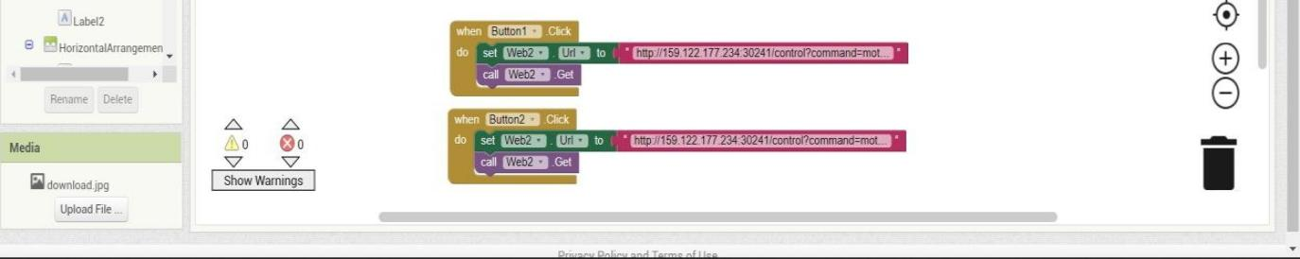

Python block that changes the state of motor based on input from app

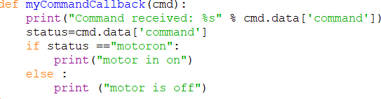

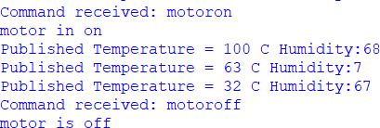Output window